GPSA 2017 CONFERENCE SCHEDULE CHEAT SHEET
Thursday, November 10 |  | Time | Place
Registration |  | 1-2:15 PM | Hilton Garden Lobby
Regents Advisory Committee |  | 2-4 PM | Cobalt Room
GPSA Executive Board Meeting |  | 4-6 PM | Cobalt Room
GPSA's President's Welcome Reception |  | 6-7:30 PM | Hilton Garden Lobby
Opening Session |  | Time | Place
Panel Session Thursday
 | Roundtable T1: What is Political Science? Is it Possible? Is it Salutary? | 2:30-3:45PM | Cobalt
 | T2: Georgia Southern Undergraduate Student Panel | 2:30-3:45PM | Amber
 | T3: Undergraduate Panel-Studying Donald Trump from a Minority Perspective | 2:30-3:45PM | Telfair
Friday, November 11 |  | Time | Place
Registration |  | 7:30-11:30/1:30-6PM | Hilton Garden Lobby
Continental Breakfast |  | 8-10:30AM | Hilton Garden Lobby
Panel Session 1 |  | 9-10:15AM
 | Roundtable 1A: Is Anybody Listening? A Consideration of the Relationship between Political Scientists and Political Practitioners |  | Habersham
 | 1B:University of Georgia Undergraduate Student Research Panel |  | Cobalt
 | 1C: American Institutions, Political Communication, and Elections |  | Amber
 | 1D: International Relations: Policy and Analysis |  | Telfair
 | 1E: State and Federal Court System |  | Summit
Panel Session 2 |  | 10:30-11:45AM
 | Roundtable 2A: International Relations: Issues, Trends, and Analysis |  | Habersham
 | 2B: International Relations and Comparative Politics |  | Cobalt
 | 2C: Undergraduate Student Research Panel |  | Amber
 | 2D: American Politics: Trends and Transition |  | Telfair
 | 2E: Conflict and Terrorism |  | Summit
Lunch: On your own |  | 11:45-1:15PM
Conference Keynote Session | Dr. Kirk Randazzo, USC | 1:30-2:30PM | Cobalt
Panel Session 3 |  | 2:45-4PM
 | Roundtable 3A: Public Administration |  | Cobalt
 | Roundtable 3B: Greg Domin Roundtable on the Presidency: The Aftermath of the 2016 Presidential Election and Advice to the New President |  | Habersham
 | 3C: Foreign Policy and International Relations |  | Amber
 | 3D: Public Administration and Public Bureaucracy |  | Telfair
 | 3E: The United Kingdom, The European Union, and Brexit |  | Summit
 | Coffee Break | 4-4:30PM
Panel Session 4 |  | 4:30-5:45PM
 | Roundtable 4A: Women and Politics |  | Habersham
 | Roundtable 4B: Political Theory and Public Opinion: Revisiting A Theory of Public Opinion After 50 Years |  | Cobalt
 | 4C: SOTL I |  | Amber
 | 4D: State and Local Politics |  | Telfair
 | 4E: International Relations: Peace and Conflict |  | Summit
European Union Executive Board Meeting |  | 4:30-6PM | Scarborough Boardroom
Student Poster Session and "Open" Bar Reception |  | 6:30-8 PM | Hilton Garden Inn Lobby
Saturday, November 12
Registration |  | 7:30-11:30AM | Hilton Garden Inn Lobby
Breakfast |  | 8-10: 15AM | Hilton Garden Inn Lobby
Panel Session 5 |  | 9-10:15AM
 | Roundtable 5A: The Impact of Nativism on Globalization in the 21st Century |  | Cobalt
 | 5B: Law, Courts, and Public Policy |  | Habersham
 | 5C: Pajari Undergraduate Panel |  | Amber
 | 5D: Public Administration and Public Policy |  | Telfair
 | 5E: SOTL II |  | Summit
Panel Session 6 |  | 10:30-11:45AM
 | Roundtable 6A: The Relevancy of the American Two Party System |  | Cobalt
 | Roundtable 6B: The Roles of Political Scientists: Key to Relevancy of the Discipline |  | Habersham
 | 6C: Teaching and Learning Consortium Panel and Workshop |  | Amber
 | 6D: International Relations: Theory and Globalization |  | Telfair
 | 6E: American Politics and Public Opinion |  | Summit
Annual Business Meeting/Association Elections/Awards |  | 12:00-1:00PM | Cobalt

2017 FULL CONFERENCE SCHEDULE
THURSDAY, NOVEMBER 10, 2016
1:00PM-2:15PM Registration—Hilton Garden Lobby
2:00PM-4:00PM Regents Advisory Committee Meeting—Cobalt Room
2:30PM-3:45PM Thursday Panel Sessions

Roundtable T1: What is Political Science? Is it Possible? Is it Salutary?
Roundtable
Room: Habersham
Panel Chair and Discussant: Mark Kremer: Kennesaw State University

Members Institution
Mark Kremer Kennesaw State University
Jack Moran Kennesaw State University
Richard Buckwalter Tilburg University
Arthur Milikh Heritage Foundation

Panel Session T2: Georgia Southern Undergraduate Student Panel
Room: Amber
Panel Chair and Discussant: Jamie Scalera—Georgia Southern University

Members Paper Title Institution
Carolynn Nixon Helping Ourselves First: Conflict Georgia Southern University
Management Strategies of Regional IOs

Auburn Bell A Socialist Revolution? Comparing the differing Georgia Southern University
perceptions of socialism in the United States and Europe

Maria Amiel Exploring the Role of Corporate Social Responsibility: Georgia Southern University
European Fashion Corporations Compliance to Ethnical
Practices

Charlotte MacDonald Policing the Traffic: The Capacity of Legal Change to Georgia Southern University
Arrest Human Trafficking in the European Union

Panel Session T3: Undergraduate Roundtable Panel—Studying Donald Trump from a Minority Perspective
Room: Telfair
Panel Chair and Discussant: Robert W. Smith—Savannah State University

Members Institution
Loren Jackson Savannah State University
Frederic Keyhea Savannah State University
Dayne Ladson Savannah State University
Thalia Kennedy Savannah State University
Mia R. Robinson Savannah State University

4:00PM-6:00PM GPSA Executive Board Meeting—Cobalt Room
6:00PM-7:30PM GPSA's President's Welcome Reception—Hilton Garden Lobby

FRIDAY, NOVEMBER 11, 2016
7:30AM-11:30AM Registration—Hilton Garden Lobby
8:00AM-10:30AM Continental Breakfast—Hilton Garden Lobby
9:00AM-5:45PM Friday Panel Sessions

9:00AM-10:15AM
1A: Is Anybody Listening?
A Consideration of the Relationship between Political Scientists and Political Practitioners
Roundtable
Room: Habersham
Panel Chair: Hans E. Schmeisser—Abraham Baldwin Agricultural College
Discussant: Andrew E. Smith—Abraham Baldwin Agricultural College

Members Institution
Roger C. Byrd East Georgia State College
Senator Steve Henson (D-Tucker) Senate Minority Leader
Senator Jeff Mullis (R-Chickamauga) Rules Committee Chairman
Senator Nan Orrock (D-Atlanta)
Former Senator Tommie Williams (R-Lyons Transportation Chair

9:00AM-10:15AM
Panel 1B: University of Georgia Undergraduate Student Panel
Room: Cobalt
Panel Chair and Discussant: James Monogan—University of Georgia

Members Paper Title Institution
Rory Hibbler Ballot Initiatives and Voter Turnout University of Georgia
Rob Oldham Factions in State Legislatures University of Georgia
Sam Glaze A Hobbesian Account of Constitutional Legitimacy University of Georgia

9:00AM-10:15AM

Panel 1C: American Institutions, Political Communications, and Elections
Room: Amber
Panel Chair and Discussant: Fred Gordon—Columbus State University

Members Paper Title Institution
Brian Webb Defying the Line: Intra-Party Faction and Procedural Dissidents Gordon State College
Jeffrey Glas in the House of Representatives Georgia State University

John Tures Do Certain Words “Trump” Others? An analysis of Lagrange College
nomination speeches by presidential candidates

Sean Richey Elite Rhetoric in the 2016 Presidential Election and Georgia State University
Attitudes towards Immigrant Assimilation

Ann Marie Not on Deaf Ears: Assessing Presidential Georgia State University
Robinson Communication with the Public

9:00AM-10:15AM

Panel 1D: International Relations: Policy and Analysis
Room: Telfair
Panel Chair and Discussant: Craig Greathouse—University of North Georgia

Members Paper Title Institution
James Walter Peterson Political Science and Territorial Borders Valdosta State University
Sarah Kuck Darton State College

Eleanor Morris Going Beyond Gender Mainstreaming? Agnes Scott College
Resettlement Programs for Refugee Women in Atlanta

Nalanda Roy The Implication of Beijing’s Movements in Asia Armstrong State University

Crystal Garrett Is China Good for Nigeria? A Case study of China’s Georgia State University
Growing Presence in Nigeria

Sudha Ratan Deconstructing the Indian state: Augusta University
The argument for state reorganization in the 21st century

9:00AM-10:15AM

1E: State and Federal Court System
Room: Summit
Panel Chair and Discussant: Martha Humphries Ginn—Augusta University

Members Paper Title Institution
Colin Glennon Judicial Elections in the Volunteer State: East Tennessee State University
What Do Tennessee Residents Know About
the Judicial Selection Process?

Marc Pufong On Account of Judgeship in Georgia: Valdosta State University
A Politically and Historically Conflicted Process

H. Chris Tecklenburg Appropriately Testing Public Knowledge Armstrong State University
Morgan Biercewicz Involving National and State Supreme Courts Armstrong State University
Roxanna Simons Armstrong State University

Clifford Humphrey James Madison's Theory of the Extended Sphere Hillsdale College
and the Psychology of Citizenship

Zhifa Zhou Zhejiang The Construction of Mistake-tolerant Democracy Normal University and
Based on the Practical Right “Right to Trial and Error” University of Florida

FRIDAY, NOVEMBER 11, 2016
10:30-11:45AM
2A: IR Roundtable: Issues of Great Power Status and Prestige
Roundtable
Room: Habersham
Panel Chair and Discussant: Thomas E. Rotnem—Kennesaw State University

Members Institution
Thomas E. Rotnem Kennesaw State University
Christos Bourdouvalis Augusta University
Craig Douglas Albert Augusta University
Tinaz Pavri Spelman College

10:30-11:45AM
2B: International Relations and Comparative Politics
Room: Cobalt
Panel Chair and Discussant: Tobias Endler: Heidelberg University

Members Paper Title Institution
John Tures Beyond Rwanda: The Role of Respect for Lagrange College
Rights in Accepting Jurisdiction
Of The African Court of Human and People’s Rights

‘Tola Odubajo Nigeria’s Quest for Peaceful Co-existence: University of Johannesburg
A Diagnosis of the Truth and Reconciliation Commission

Olukayode Segun Eesuola The University System, Youth Socialization and the North West University,
Political Development of Nigeria Republic of South Africa

Napoleon A. Bamfo Reflecting on Africa's Tripartite Problems of Child Marriage, Valdosta State University
Low Productivity, and Corruption: Are Governments Doing
Enough?

Behrooz Kalantari People's Misperception and Misunderstanding about an Savannah State University
All-Powerful Dictator: The Life of the Shah of Iran before
the Revolution of 1979

10:30-11:45AM
2C: Undergraduate Student Research Panel
Room: Amber
Panel Chair and Discussant: Kristina LaPlant—Georgia State University

Members Paper Title Institution
David Bennett The Economy of Terror: Relative Student, Shepherd University
Deprivation in Tajikistan and Azerbaijan

Miguel Lo Analyzing Immigration and Security in Student, Armstrong State
Post 9/11 United States University

Zachary T Pine Barack Obama: The Modern Conspiracy President Student, Valdosta State
University

Alex Avina Violations of Human Rights in North Korea Student, Armstrong State
University

Victoria Isom Religion and Juvenile Sentence Length Student, Georgia State University

10:30-11:45AM
2D: American Politics: Trends and Transition
Room: Telfair
Panel Chair and Discussant: James P. (Jamie) Todhunter—Troy University

Members Paper Title Institution
Barry J. Balleck The Patriot Myth: How Armed Groups Justify Georgia Southern University
Violence in the Name of Nationalism

Lucas Osborne Understanding Leftist Political Movements in Graduate Student,
Present-Day Europe: Discourse Analysis, Hegemony, Brandeis University
and Laclau

Mary-Kate Lizotte Gender Differences in Support for Gay Rights: Augusta University
The Role of Religiosity and Anti-Federal Government Attitudes

10:30-11:45AM
2E: Conflict and Terrorism
Room: Summit
Panel Chair and Discussant: Amit Gupta—United States Air Force Air War College

Members Paper Title Institution
Joseph Robbins Economics and Terrorism Revisited: Shepherd University
David Bennett Relative Dependence and Terrorist Activity Student, Shepherd University

Lance Y. Hunter Mass Murder and Terrorism Augusta University
Scott Storyllewellyn Student, Augusta University
Martha Ginn Augusta University

Aleksandar Jankovski International Terrorism and the Role of Great Powers: Northeastern Illinois University
Towards an International Society Approach

Tony Hudson The Lethality of Home-Grown Terrorism Student, Georgia Southern
in the United States University
Srobana Bhattacharya Georgia Southern University
James N. Eastman III Crisis at the Third Pole: Global Warming, Water Security, Independent Researcher
and Conflict in the Himalayan Watershed

11:45AM-1:15PM Lunch: On your Own
1:30PM-6:00PM Registration—Hilton Garden Lobby

1:30PM-2:30PM Keynote Speaker: Dr. Kirk Randazzo, PhD
University of South Carolina
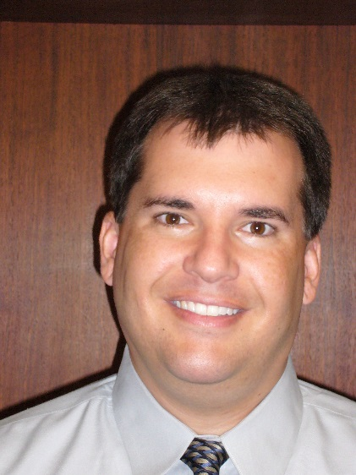

Dr. Kirk A. Randazzo is a highly sought speaker and scholar, both internationally and across the United States. As a respected political scientist, he teaches and conducts research on constitutional law and judicial politics, the rule of law in emerging democracies, and judicial independence. As a public speaker, his presentations focus on developing fundamental leadership skills and strategies for successful conflict management, team motivation, and public speaking. From 2013-2016 he served as the Director of the Carolina Leadership Initiative where he developed and implemented a new Minor in Leadership Studies for the University of South Carolina and helped undergraduate students focus on developing leadership skills. Dr. Randazzo received a bachelor’s degree in Music (in 1994) and a master’s degree in International Studies (in 1997) from the University of South Carolina and a master’s degree (in 2000) and Ph.D. in political science from Michigan State University in 2003. From 2003-2008 he taught at the University of Kentucky and in 2008 returned to his alma mater as a Professor of Political Science at the University of South Carolina. He also serves on various boards including Leadership Columbia, the USC Alumni Band, and is the ‘Voice of the Carolina Band’. Kirk has published in top journals including, American Journal of Political Science, Journal of Politics, American Politics Research, and Political Research Quarterly, to name a few! His book, Defenders of Liberty or Champions of Security? Federal Courts, the Hierarchy of Justice, and U.S. Foreign Policy, published by SUNY Press in 2010, has been well-received!
FRIDAY, NOVEMBER 11, 2016
2:45PM-4:00PM
3A: Public Administration
Room: Cobalt
Panel Chair and Discussant: Wesley Meares—Augusta University

Members Paper Title Institution

Saundra J. Ribando Apples to Apples? Augusta University
Catherine P. Slade Comparing University Consolidations Augusta University
C. Kevin Fortner Augusta University

Erika Broussard Reframing Consolidations: Using Frames to Examine MPA Student, Augusta
London Smith a University Consolidation University
MPA Student, Augusta
University

Jenna Rodgers A Comparative Analysis of Sexual Assault Policies Graduate Student, University of
Among 4 USG Institutions North Georgia

Greg Gates Labor Market Outcomes, an Intervening Variable DPA student, Valdosta State
between Educational Attainment and Criminal Activity University

2:45PM-4:00PM
3B: Greg Domin Roundtable on the Presidency: The Aftermath of the 2016 Presidential Election and Advice to the New President
Roundtable
Room: Habersham
Panel Chair and Discussant: Adam Stone—Georgia State University

Members Institution
Wendell Broadwell Georgia State University
Carl Cavalli University of North Georgia
Chris Grant Mercer University
Lori Johnson Mercer University
Stacey Kirkland Georgia State University
Hans Schmeisser Abraham Baldwin Agricultural
College
Kerry Stewart University of North Georgia
Douglas Young University of North Georgia
Adam Stone Georgia State University

2:45PM-4:00PM
3C: Foreign Policy and International Relations
Room: Amber
Panel Chair and Discussant: ‘Tola Odubajo—University of Johannesburg

Members Paper Title Institution

Jonathan S. Miner The Mission of the Military in Making United States University of North Georgia
Foreign Policy: A View from Future Military Officers

Tobias Endler Hold Your Own in the Marketplace of Ideas: Foreign Policy Heidelberg University
Intellectuals and the Relevancy of Political Science in the 21st
Century

Amit Gupta The Lassie Syndrome: The Inbreeding of American United States Air Force Air War
Political Science and the Challenge to Public Relevancy College

Peter Ajongwa Ngwafu Russia’s Role in the Iran Nuclear Treaty Albany State University
Olukayode Segun Eesuola Explaining Political Agitators: Socialization and Class North West University
in the Making of Gani Fawehinmi and Fela Anikulapo Republic of South Africa
Kuti of Nigeria

2:45PM-4:00PM
3D: Public Administration and Public Bureaucracy
Room: Telfair
Panel Chair and Discussant: Saundra J. Ribando—Augusta University

Members Paper Title Institution

Willie Green Public Bureaucrats and Election Director of Elections,
Administration and Resource & Registration Floyd County,
Allocation Outside Atlanta Georgia

Ashley L. McCready Representative Bureaucracy and Social Work: Graduate Student,
Evaluating the Representation of America's Poor Georgia College and State University

Jennifer Porter The Effect of the Independent Living Program on Graduate Student, Valdosta State
Educational Engagement for Former Foster University
Youth during Emerging Adulthood

David R. Shock Demographic and Political Transformations at the Kennesaw State University
Local Level in Metropolitan Atlanta

2:45PM-4:00PM
3E: The United Kingdom, The European Union, and Brexit
Room: Summit
Panel Chair and Discussant: Allynne Tosca Owens—Savannah State University

Members Paper Title Institution

Carol Glen The Unraveling of the Union? Valdosta State University
Kristina LaPlant Brexit, Scottish Independence and the Doctoral Student, Georgia State
Future of the United Kingdom University
James LaPlant Valdosta State University

Nathan Price Brexit Vote: Will it Matter? University of North Georgia
Hank Edmondson Where Do the Go from Here? Georgia College and State
The European Union and Political Philosophy University

James N. Eastman III Bargaining and Negotiations in 21st Century International Independent Researcher
Relations

Randy Carter Stockholm Syndrome and Public Bureaucracies East Georgia State College

FRIDAY, NOVEMBER 11, 2016
4:00PM-4:30PM Coffee Break
4:30PM-5:45PM
4A: Women and Politics
Roundtable
Room: Habersham
Panel Chair and Discussant: Tamra Ortgies Young—Georgia State University

Members Institution
Eleanor Morris Agnes Scott College
Crystal Garrett Georgia State University
Kimberley Gill Columbus State University
Brandy Kennedy Georgia College and State
University
Ann Marie Robinson Georgia State University

4:30PM-5:45PM
4B: Political Theory and Public Opinion: Revisiting A Theory of Public Opinion After 50 Years
Roundtable
Room: Cobalt
Panel Chair and Discussant: H. Lee Cheek, Jr.—East Georgia State College

Members Institution
Hans E. Schmeisser Abraham Baldwin Agricultural
College
Daniel Mancill East Georgia State College
Craig Albert Augusta University
James LaPlant Valdosta State University
Brett Larson East Georgia State College

4:30PM-5:45PM
4C: The Scholarship of Teaching and Learning I
Room: Amber
Panel Chair and Discussant: Adam Stone—Georgia State University

Members Paper Title Institution

Karen M. McCurdy Learning to Do Democracy: Georgia Southern University
Teaching the Good, the Bad and the Ugly

Lance Bardsley Popular Culture, Pedagogy, and Interdisciplinarity University of North Georgia
Dan Cabaniss in a Course on the Politics of the Cold War and American Film University of North Georgia

Douglas E. Ealey The Importance of American Government University of North Georgia
as a Required Academic Course

4:30PM-5:45PM
4D: State and Local Politics
Room: Telfair
Panel Chair and Discussant: Colin Glennon—East Tennessee State University

Members Paper Title Institution

William Hatcher City-County Consolidation and Fiscal Health: Augusta University
Wesley Meares A Quasi-Experimental Study Augusta University

Min Su Kim Ideological Thinking in Policy Attitudes and Georgia College and State
Perceptions: The 2016 Georgia’s State of the State University
Costas Spirou Poll Georgia College and State
University

Chris Roskilly Who Feels the Squeeze of Atlanta’s New Belt? Valdosta State University
Kristina LaPlant A Longitudinal Analysis of Gentrification Trends Georgia State University
in the Atlanta Beltline Brownfield Initiative

Willie Green City-County Consolidation: Minority Political Green Group Consulting, LLC
Participation in Rural Georgia

Kerry R. Stewart Closet Segregation in Northern Cities: Toledo, Ohio 1949-1963 University of North Georgia

4:30PM-5:45PM
4E: International Relations: Peace and Conflict
Room: Summit
Panel Chair and Discussant: Sudha Ratan—Augusta University

Members Paper Title Institution

Jamie Scalera When Relations Sour: Does WTO Membership Predict Peace? Georgia Southern University
Srobana Bhattacharya Georgia Southern University

Daniel Gozan Military Coups Attempts in Nascent Democracies Student, Augusta University
Lance Y. Hunter Augusta University

Jose de Arimateia da Cruz Gangs in Latin America: A Generational Approach Armstrong State University
James Madison Marye and Implications for U.S. National Security Student, Armstrong State
University

Kwame B. Dankwa Russia’s Middle East Policy in the Twenty-First Century Albany State University

FRIDAY, NOVEMBER 11, 2016
4:30PM-6:00PM European Union Executive Board Meeting--Scarborough Boardroom
6:30PM-8:30PM Student Poster Session and “Open” Bar Reception—Hilton Garden Inn Lobby
Student Poster Session
Members Poster Title Institution

SATURDAY, NOVEMBER 12, 2016

7:30AM-10:30AM Registration—Hilton Garden Lobby
8:00AM-10:15AM Continental Breakfast—Hilton Garden Lobby
9:00AM-11:45AM Saturday Panel Sessions

9:00AM-10:15AM
5A: The Impact of Nativism on Globalization in the 21st Century
Roundtable
Room: Cobalt
Panel Chair and Discussant: Allynne Tosca Owens—Savannah State University

Members Institution
Otilia Iancu Savannah State University
Emmanuel Naniueyi, Sr. Savannah State University
Benn Bongang Savannah State University
Edoh Agbehonou Savannah State University

9:00AM-10:15AM
5B: Law, Courts and Public Policy
Room: Habersham
Panel Chair and Discussant: H. Chris Tecklenburg—Armstrong State University

Members Paper Title Institution

James Larry Taulbee Citizenship and the Presidency: Emory University
Parsing Article II.1 (5) of the US Constitution

Maureen Stobb Knowledge is Power: Filling the Courts’ Georgia Southern University
Information Gap in Foreign Policy Cases

Adam Rutkowski Biggest Loser? Obama’s Administrative Student, Augusta University
Allison Vick Agencies and the Supreme Court MPA Student, Augusta
University
Lance Hunter Augusta University
Martha Ginn Augusta University

Will Miller The Social Psychology of Gun Ownership Flagler College
Elaina Seyfang Flagler College

Neena Banerjee Are Schools with Ethno-Racially Diverse Teachers Valdosta State University
Better in Engaging Diverse Parents? An Examination of the
Structures of Inclusion in Elementary Schools in the U.S.

9:00AM-10:15AM
5C: Pajari Undergraduate Panel
Room: Amber
Panel Chair: Kristina LaPlant—Georgia State University
Panel Discussant: Keith Lee—Georgia College and State University

Members Paper Title Institution

Aidan W. Lawson Measuring Economic Development: Kennesaw State University
Faculty Sponsor: Dr. April Johnson Moving Past GDP Per Capita

Ivanka Bergova Trust in the State Courts: Georgia State University
Faculty Sponsor: Dr. Amy Steigerwalt Hispanic and African American Communities

Obediah Hall 31 in a Billion: An Analysis of the Adoption Valdosta State University
Faculty Sponsor: Dr. James LaPlant of Voter ID Laws

Sydney Aronson The Battle that Started it All: The Battle of the Marne LaGrange College
Faculty Sponsor: Dr. John Tures

9:00AM-10:15AM
5D: Public Administration and Public Policy
Room: Telfair
Panel Chair and Discussant: William Hatcher—Augusta University

Members Paper Title Institution

Bryan LaBrecque Terrorism and General Aviation Clayton State University
Rodger Bates Clayton State University

Roger C. Byrd Incarceration and Education: Everything has a Price East Georgia State College

John R. Bennett Pedaling Politics: The Influence of Bicycle Valdosta State University
Advocacy on Public Policy

Brent Friedman American Exceptionalism: Public, Non-Profit DPA Student, Valdosta State
Hospitals with For-Profit Agendas University

Douglas E. Ealey The Black Ice Syndrome Myth: Formulating a University of North Georgia
Theoretical Framework, Analyzing Conceptual Tenets,
and Deconstructing the Myth Defining the Conflictual
Relationship between Black Males and Law Enforcement

9:00AM-10:15AM
5E: The Scholarship of Teaching and Learning II
Room: Summit
Panel Chair and Discussant: Craig Douglas Albert—Augusta University

Members Paper Title Institution

Robert W. Smith The Trump Factor in American Politics: Savannah State University
An Opportunity to Bridge Political Science
and Politics?

Brooke M. Miller Getting Past the “Trending Topics”: Middle Georgia State University
Rebecca Nees Measuring Student Knowledge of Current Middle Georgia State University
Events and Government

Tamra Ortgies Young A Little Assist from the President: Igniting Civic Georgia State University
Engagement in American Government Students

SATURDAY, NOVEMBER 12, 2016

10:30AM-11:45AM
6A: The Relevancy of the American Two Party System
Roundtable
Room: Cobalt
Panel Chair and Discussant: Allynne Tosca Owens—Savannah State University

Members Institution
Otis S. Johnson Savannah State University
Geoffery Bowden Savannah State University
Carl “Bruce” Mallard Savannah State University
Meldon Hollis Savannah State University

10:30AM-11:45AM
6B: The Roles of Political Scientists: Key to Relevancy of the Discipline
Room: Amber
Panel Chair and Discussant: Lee M. Allen—Valdosta State University

Members Paper Title Institution

Lee M. Allen Three Roles for Political Scientists Valdosta State University

Marc Pufong Teaching Political Science: Social Contract Valdosta State University
Theory and the Importance of Continued Civic
Engagement

Kendra H. Hollern Mentors for Students Valdosta State University

Alvin Payton Jr. Political Scientists and Counseling: Key to Relevancy Wiregrass Technical College
and Recruitment

10:30AM-11:45AM
6C: Teaching and Learning Consortium Panel and Workshop
Room: Habersham
Panel Chair and Discussant: Craig Douglas Albert—Augusta University

Members Paper Title Institution

Saundra J. Ribando Teaching the Election in a Research Methods Course Augusta University

John A. Tures “Feeling the Bern” And “Trumped Up Charges” In LaGrange College
The Classroom: How Undergraduate Research Can
Be Of "Primary" Importance

Tamra Ortgies Young Going Deeper: Inspiring Critical Thinking about U.S. Georgia State University
Presidential Election Debates

Craig Douglas Albert Examining Candidate Worldview: Augusta University
Comparing and Contrasting Clinton and Trump
through the Council of Foreign Relations

Robert W. Smith Teaching Donald Trump Savannah State University

Mary-Kate Lizotte Election Post-Mortem Activity Augusta University

10:30AM-11:45AM
6D: International Relations: Theory and Globalization
Room: Telfair
Panel Chair and Discussant: Christos Bourdouvalis—Augusta University

Members Paper Title Institution

Craig Greathouse Neoclassical Realism and CSDP University of North Georgia

Mehmet Ondur The Influence of Political Agreement PhD Candidate, Wayne State
and Sanctions Effectiveness University

Amit Gupta The Impact of Globalization on United States Air Force Air War
International Sporting Events College

Clay Fuller Special Economic Zones as ABD, University of South
Power-Sharing Institutions in Dictatorships Carolina

Thomas E. Rotnem Putin’s “Eastern Pivot”: Divergent Ambitions Kennesaw State University
between Russia and China?

10:30AM-11:45AM
6E: American Politics and Public Opinion
Room: Summit
Panel Chair and Discussant: John R. Bennett—Valdosta State University

Members Paper Title Institution

Jamie Monogan The Rhetoric of Healthcare: A Topic Model University of Georgia
James Strickland of Congressional Speeches, 1945-2010 Ph.D. Student, University of
Michigan
Ryan Williamson Ph.D. Student, University of
Georgia

James P. (Jamie) Todhunter Elections, Payoffs, and Commitment: Troy University
Electoral Cycles and the Offer of Mediation

Robert M. Sanders The Most Popular Impeached President University of West Georgia

Fred Gordon Environmental Executive Orders: Columbus State University
New Pattern or New Institutionalism?

Seth C. McKee Generational Change and GOP Growth Texas Tech University

SATURDAY, NOVEMBER 12, 2016
12:00PM-1:00PM Annual Business Meeting/Association Elections/Awards—Cobalt Room
1:00PM ADJOURNMENT

2016 GPSA EXECUTIVE BOARD & OFFICERS
PRESIDENT | TAMRA ORTGIES-YOUNG | GEORGIA STATE UNIVERSITY
IMMEDIATE PAST PRESIDENT | JAMES LAPLANT | VALDOSTA STATE UNIVERSITY
VICE PRESIDENT AND PROGRAM CHAIR, 2016 CONFERENCE | CRAIG DOUGLAS ALBERT | AUGUSTA UNIVERSITY
VICE PRESIDENT AND PROGRAM CHAIR-DESIGNATE, 2017 CONFERENCE | MATTHEW HIPPS | DALTON STATE COLLEGE
SECRETARY | TOM ROTNEM | KENNESAW STATE UNIVERSITY
TREASURER | BRANDY KENNEDY | GEORGIA COLLEGE AND STATE UNIVERSITY
COMMUNICATION OFFICER | JOHN BENNETT | VALDOSTA STATE UNIVERSITY
EDITORS,  QUESTIONS IN POLITICS | ADAM STONE | GEORGIA STATE UNIVERSITY
 | TOM ROTNEM | KENNESAW STATE UNIVERSITY
DEVELOPMENT COORDINATOR | CRYSTAL GARRETT | GEORGIA PERIMETER COLLEGE
TEACHING AND LEARNING COORDINATOR | CRAIG DOUGLAS ALBERT | AUGUSTA UNIVERSITY
BOARD MEMBERS THROUGH 2017 | MATTHEW HIPPS | DALTON STATE COLLEGE
 | ROBERT KING | GEORGIA STATE UNIVERSITY
 | MARTHA GINN | AUGUSTA UNIVERSITY
 | AUGUSTINE AYUK | CLAYTON STATE UNIVERSITY
BOARD MEMBERS THROUGH 2016 | RANDY MOFFETT | SAVANNAH COLLEGE OF ART & DESIGN
 | KIMBERLY GILL | COLUMBUS STATE UNIVERSITY
 | ELEANOR MORRIS | AGNES SCOTT COLLEGE
 | GERALD NEUMARK | GEORGIA STATE UNIVERSITY

CONFERENECE EMAIL LIST
Panelists | E-Mail Address
Adam Rutkowski: Student, Augusta University | ARUTKOW1@augusta.edu
Adam Stone: Georgia State University | astone@gsu.edu
Aidan W. Lawson: Kennesaw State University/Faculty Sponsor: Dr. April Johnson | aidanlawson@hotmail.com
Aleksandar Jankovski: Northeastern Illinois University | a-jankovski@neiu.edu
Alex Avina: Student, Armstrong State University | aa7952@stu.armstrong.edu
Allison Vick: MPA Student, Augusta University | AVICK@augusta.edu
Allynne Tosca Owens: Savannah State University | owensa@savannahstate.edu
Alvin Payton Jr.: Wiregrass Technical College | alvin.payton@wiregrass.edu
Amit Gupta: United States Air Force Air War College | amit.gupta1856@gmail.com
Andrew E. Smith: Abraham Baldwin Agricultural College
Ann Marie Robinson: Georgia State University | acraig4@gsu.edu
Arthur Milikh: Heritage Foundation | a.milikh@gmail.com
Ashley L. McCready: Graduate Student, Georgia College and State University | ashley.mccready@bobcats.gcsu.edu
Auburn Bell: Student, Georgia Southern University | ab10785@georgiasouthern.edu
Barry J. Balleck: Georgia Southern University | bballeck@georgiasouthern.edu
Behrooz Kalantari: Savannah State University | kalantab@savannahstate.edu
Benn Bongang: Savannah State University | bongang@savannahstate.edu
Brandy Kennedy: Georgia College and State University | brandy.kennedy@gcsu.edu
Brent Friedman: DPA Student, Valdosta State University | bafriedman@valdosta.edu
Brett Larson: East Georgia State College | brettlarson86@gmail.com
Brian Webb: Gordon State College | bwebb@gordonstate.edu
Brooke M. Miller: Middle Georgia State University | brookemerrett11@outlook.com
Bryan LaBrecque: Clayton State University | BryanLaBrecque@clayton.edu
C. Kevin Fortner: Augusta University | kevin@thefortners.com
Carl “Bruce” Mallard: Savannah State University | mallardb@savannahstateedu.onmicrosoft.com
Carl Cavalli: University of North Georgia | Carl.Cavalli@ung.edu
Carol Glen: Valdosta State University | cmglen@valdosta.edu
Carolynn Nixon: Student, Georgia Southern University | cn01553@georgiasouthern.edu
Catherine P. Slade: Augusta University | CSLADE@augusta.edu
Charlotte MacDonald: Student, Georgia Southern University | cm08118@georgiasouthern.edu
Chris Grant: Mercer University | grant_jc@mercer.edu
Chris Roskilly: Valdosta State University | crroskilly@valdosta.edu
Christos Bourdouvalis: Augusta University | CBOURDOU@augusta.edu
Clay Fuller: ABD, University of South Carolina | fullercr@email.sc.edu
Clifford Humphrey: Graduate Student Hillsdale College | Chumphrey@hillsdale.edu
Colin Glennon: East Tennessee State University | GLENNON@mail.etsu.edu
Costas Spirou: Georgia College and State University | costas.spirou@gcsu.edu
Craig Douglas Albert: Augusta University | calbert@augusta.edu
Craig Greathouse: University of North Georgia | Craig.Greathouse@ung.edu
Crystal Garrett: Georgia State University | cgarrett@gsu.edu
Dan Cabaniss: University of North Georgia | dan.cabaniss@ung.edu
Daniel Gozan: Student, Augusta University | DGOZAN@augusta.edu
Daniel Mancill: East Georgia State College | dmancill@ega.edu
David Bennett: Student, Shepherd University | DBENNE07@rams.shepherd.edu
David R. Shock: Kennesaw State University | dshock@kennesaw.edu
Dayne Ladson: Student, Savannah State University | dladson1@savstate.view.usg.edu
Douglas E. Ealey: University of North Georgia | Douglas.Ealey@ung.edu
Douglas Young: University of North Georgia | Douglas.Young@ung.edu
Edoh Agbehonou: Savannah State University | edoha@savannahstateedu.onmicrosoft.com
Elaina Seyfang: Flagler College | eseyfang578@flagler.edu
Eleanor Morris: Agnes Scott College | emorris@agnesscott.edu
Emmanuel Naniueyi, Sr.: Savannah State University | naniuze@savannahstate.edu
Erika Broussard: MPA Student, Augusta University | EBROUSSARD@augusta.edu
Former Senator Tommie Williams: Transportation Chair (R-Lyons)
Fred Gordon: Columbus State University | gordon_frederick@columbusstate.edu
Frederic Keyhea: Student, Savannah State University | fkeyhea@savstate.view.usg.edu
Geoffery Bowden: Savannah State University | bowdeng@savannahstate.edu
Greg Gates: DPA student, Valdosta State University | gsgates@valdosta.edu
H. Chris Tecklenburg: Armstrong State University | chris.tecklenburg@armstrong.edu
H. Lee Cheek, Jr., East Georgia State College | lcheek@ega.edu
Hank Edmondson: Georgia College and State University | hank.edmondson1@mac.com
Hans E. Schmeisser: Abraham Baldwin Agricultural College | hschmeisser@abac.edu
Ivanka Bergova: Georgia State University/Faculty Sponsor: Dr. Amy Steigerwalt | ibergova1@student.gsu.edu
Jack Moran: Kennesaw State University | jmoran@kennesaw.edu
James LaPlant: Valdosta State University | jlaplant@valdosta.edu
James Larry Taulbee: Emory University | psjt@emory.edu
James Madison Marye: Student, Armstrong State University | jm9654@stu.armstrong.edu
James Monogan: University of Georgia | monogan@uga.edu
James N. Eastman III: Independent Researcher | eastj3@aol.com
James P. (Jamie) Todhunter: Troy University | jtodhunter@troy.edu
James Strickland: Ph.D. Student, University of Michigan | strickl@umich.edu
James Walter Peterson: Valdosta State University | jpetersn@valdosta.edu
Jamie Monogan: University of Georgia | monogan@uga.edu
Jamie Scalera: Georgia Southern University | jscalera@georgiasouthern.edu
Jeffrey Glas: Georgia State University | jeffreyglas@gmail.com
Jenna Rodgers: Graduate Student, University of North Georgia | jrrodg1451@ung.edu
Jennifer Porter: Graduate Student, Valdosta State University | jenjen101010@hotmail.com
John A. Tures: LaGrange College | jtures@lagrange.edu
John R. Bennett: Valdosta State University | jobennett@valdosta.edu
Jonathan S. Miner: University of North Georgia | Jonathan.Miner@ung.edu
Jose de Arimateia da Cruz: Armstrong State University | jose.dacruz@armstrong.edu
Joseph Robbins: Shepherd University | JROBBINS@shepherd.edu
Karen M. McCurdy: Georgia Southern University | kmccurdy@georgiasouthern.edu
Keith Lee: Georgia College and State University | keith.lee@gcsu.edu
Kendra H. Hollern: Valdosta State University | kahinton@valdosta.edu
Kerry R. Stewart: University of North Georgia | Kerry.Stewart@ung.edu
Kimberley Gill: Columbus State University | gill_kimberly1@columbusstate.edu
Kristina LaPlant: Doctoral Student, Georgia State University | klaplant1@gsu.edu
Kwame B. Dankwa: Albany State University | kwame.dankwa@asurams.edu
Lance Bardsley: University of North Georgia | Lance.Bardsley@ung.edu
Lance Y. Hunter: Augusta University | LAHUNTER@augusta.edu
Lee M. Allen: Valdosta State University | lallen@valdosta.edu
London Smith: MPA Student, Augusta University | LSMITH58@augusta.edu
Loren Jackson: Student, Savannah State University | ljacks42@savstate.view.usg.edu
Lori Johnson: Mercer University | johnson_la@mercer.edu
Lucas Osborne: Graduate Student, Brandeis University | lukeosborne@brandeis.edu
Marc Pufong: Valdosta State University | mpufong@valdosta.edu
Maria Amiel: Student, Georgia Southern University | ma03261@georgiasouthern.edu
Mark Kremer: Kennesaw State University | mkremer@kennesaw.edu
Martha Humphries Ginn: Augusta University | mginn@augusta.edu
Mary-Kate Lizotte: Augusta University | MLIZOTTE@augusta.edu
Maureen Stobb: Georgia Southern University | mstobb@georgiasouthern.edu
Mehmet Ondur: PhD Candidate, Wayne State University | mehmet.ondur@wayne.edu
Meldon Hollis: Savannah State University | hollism@savannahstateedu.onmicrosoft.com
Mia R. Robinson: Student, Savannah State University | mrobin33@student.savannahstate.edu
Miguel Lo: Student, Armstrong State University | ml2232@stu.armstrong.edu
Min Su Kim: Georgia College and State University | min.kim@gcsu.edu
Morgan Biercewicz: Student, Armstrong State University | mb9867@stu.armstrong.edu
Nalanda Roy: Armstrong State University | nalanda.roy@armstrong.edu
Napoleon A. Bamfo: Valdosta State University | nbamfo@valdosta.edu
Nathan Price: University of North Georgia | Nathan.Price@ung.edu
Neena Banerjee: Valdosta State University | nbanerjee@valdosta.edu
Obediah Hall: Valdosta State University/Faculty Sponsor: Dr. James LaPlant | oehall@valdosta.edu
Olukayode Segun Eesuola: North West University, Republic of South Africa | foomoterribly@yahoo.com
Otilia Iancu: Savannah State University | iancuo@savannahstate.edu
Otis S. Johnson: Savannah State University | otisjohn@aol.com
Peter Ajongwa Ngwafu: Albany State University | peter.ngwafu@asurams.edu
Randy Carter: East Georgia State College | rcarter@ega.edu
Rebecca Nees: Middle Georgia State University | rebecca.nees@mga.edu
Richard Buckwalter: Tilburg University | r.a.buckwalter@gmail.com
Rob Oldham: Student, University of Georgia | roboldham24@gmail.com
Robert M. Sanders: University of West Georgia | bsanders@westga.edu
Robert W. Smith: Savannah State University | smithro@savannahstate.edu
Rodger Bates: Clayton State University | RodgerBates@clayton.edu
Roger C. Byrd: East Georgia State College | rcbyrd@ega.edu
Rory Hibbler: Student, University of Georgia | rory.hibbler25@uga.edu
Roxanna Simons: Student, Armstrong State University | rs9955@stu.armstrong.edu
Ryan Williamson: Ph.D. Student, University of Georgia | ryandw10@uga.edu
Sam Glaze: Student, University of Georgia | skglaze@uga.edu
Sarah Kuck: Darton State College | sarah.kuck@darton.edu
Saundra J. Ribando: Augusta University | SRIBANDO@augusta.edu
Scott Storyllewellyn: Student, Augusta University | scott.storyllewellyn@gmail.com
Sean Richey: Georgia State University | srichey@gsu.edu
Senator Jeff Mullis: Rules Committee Chairman (R-Chickamauga)
Senator Nan Orrock: (D-Atlanta)
Senator Steve Henson: Senate Minority Leader (D-Tucker)
Seth C. McKee: Texas Tech University | sc.mckee@ttu.edu
Srobana Bhattacharya: Georgia Southern University | sbhattacharya@georgiasouthern.edu
Stacey Kirkland: Georgia State University | staceypb83@gmail.com
Sudha Ratan: Augusta University | sratan@augusta.edu
Sydney Aronson: LaGrange College/Faculty Sponsor: Dr. John Tures | sqaronson@student.lagrange.edu
Tamra Ortgies Young: Georgia State University | tortgiesyoung@gsu.edu
Thalia Kennedy: Student, Savannah State University | tkenne10@savstate.view.usg.edu
Thomas E. Rotnem: Kennesaw State University | trotnem@kennesaw.edu
Tinaz Pavri: Spelman College | tpavri@spelman.edu
Tobias Endler: Heidelberg University | tendler@hca.uni-heidelberg.de
‘Tola Odubajo: University of Johannesburg | festod@yahoo.com
Tony Hudson: Student, Georgia Southern University | th04402@georgiasouthern.edu
Victoria Isom: Georgia State University | visom1@student.gsu.edu
Wendell Broadwell: Georgia State University | wbroadwell@gsu.edu
Wesley Meares: Augusta University | WMEARES@augusta.edu
Will Miller: Flagler College | WMiller@flagler.edu
William Hatcher: Augusta University | WIHATCHER@augusta.edu
Willie Green: Director of Elections & Registration, Floyd County, Georgia | willieiiigreen@gmail.com
Willie Green: Green Group Consulting, LLC | willieiiigreen@gmail.com
Zachary T Pine: Student, Valdosta State University | ztpine@valdosta.edu
Zhifa Zhou: Zhejiang Normal University and University of Florida | zhouhanshan@qq.com

CONFERENCE ROOM MAPS (Note: Grand Ballroom Hilton Garden Inn is divided into two spaces: Habersham and Telfair).
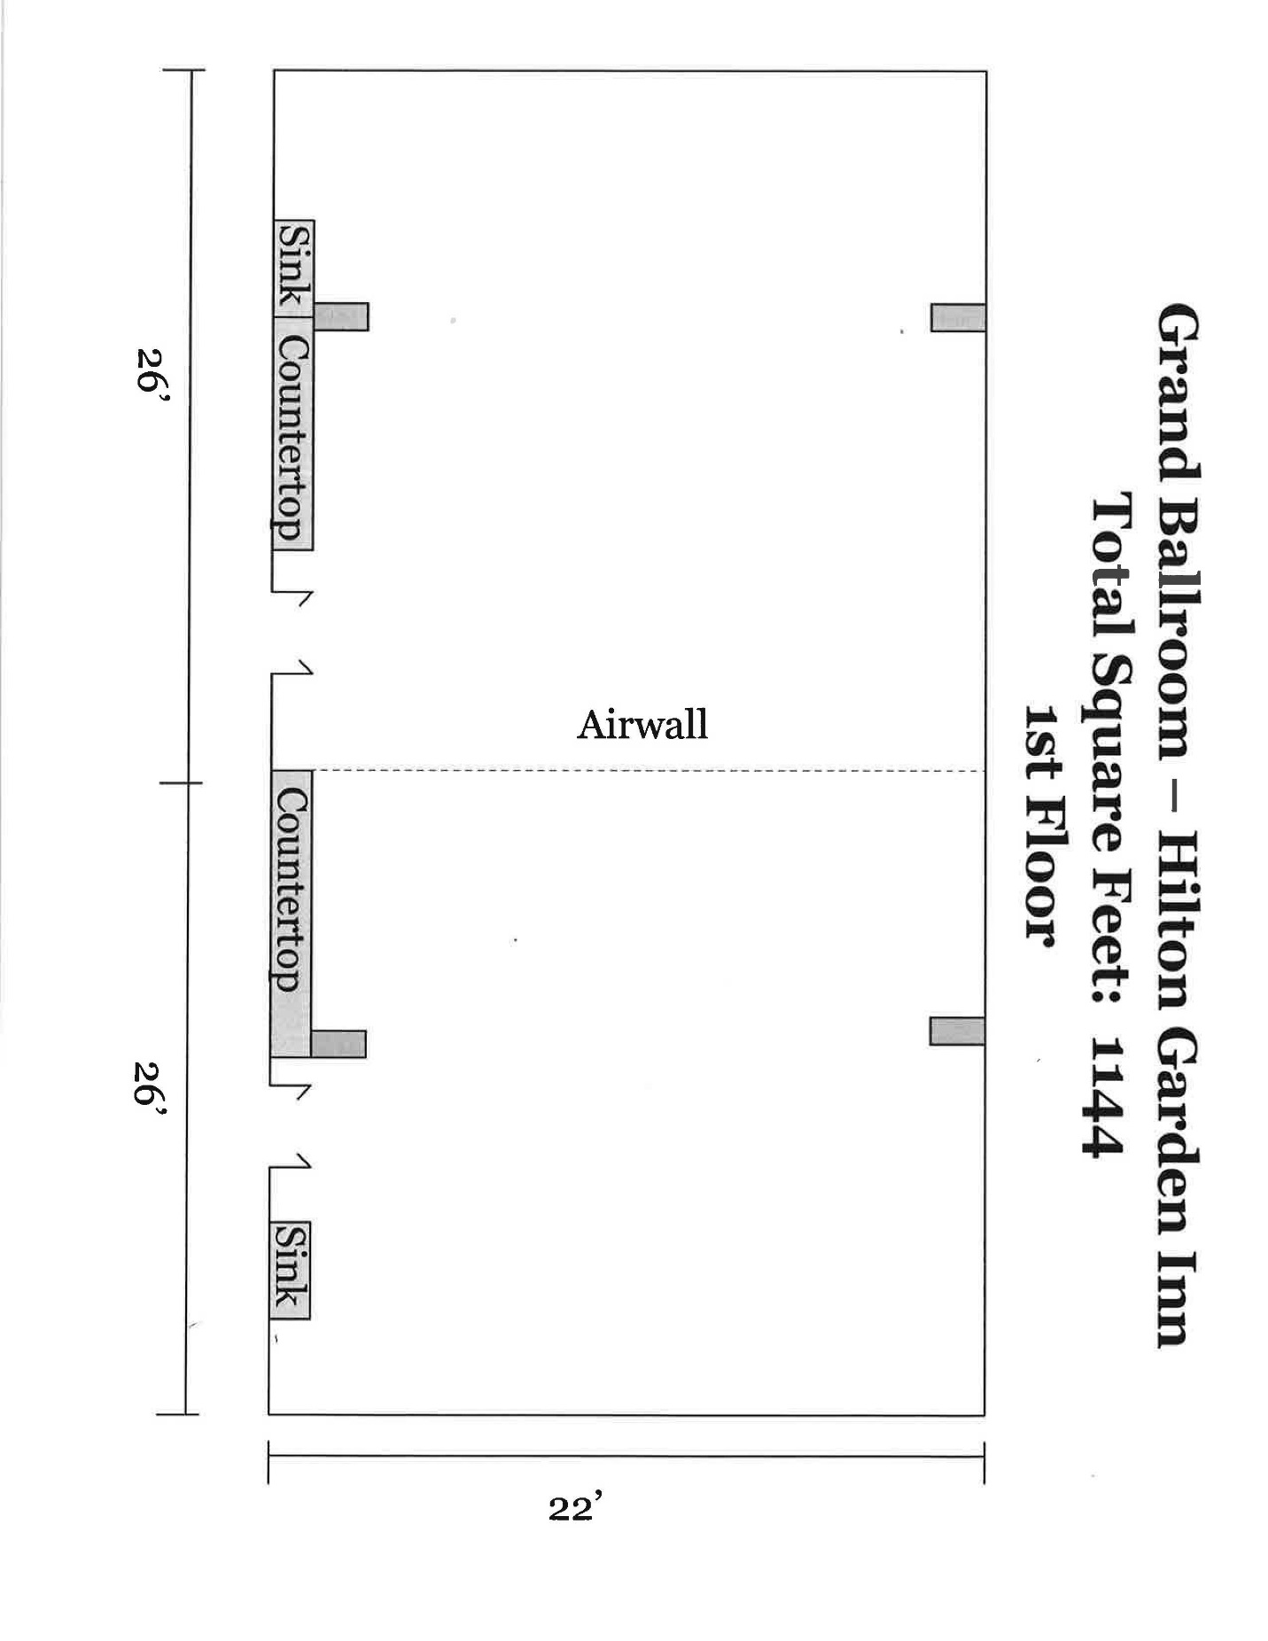
Note: Grand Ballroom—Hilton Garden Inn becomes Habersham and Telfair when divided.
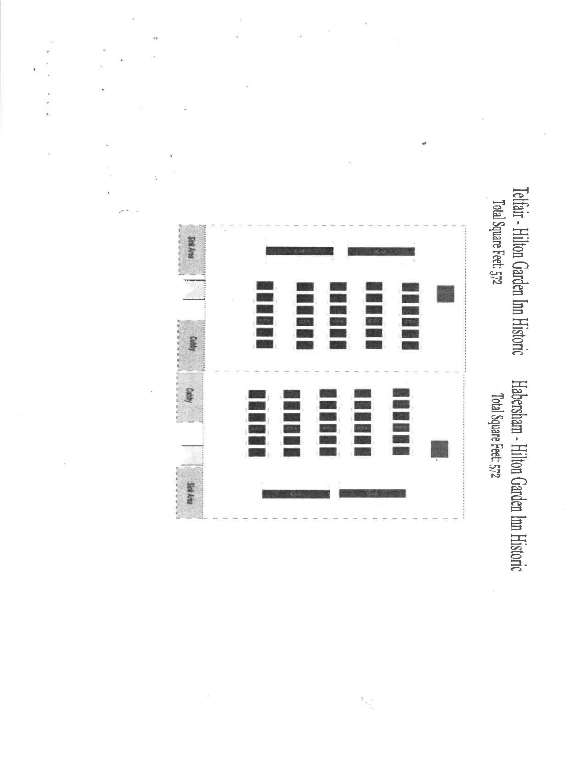
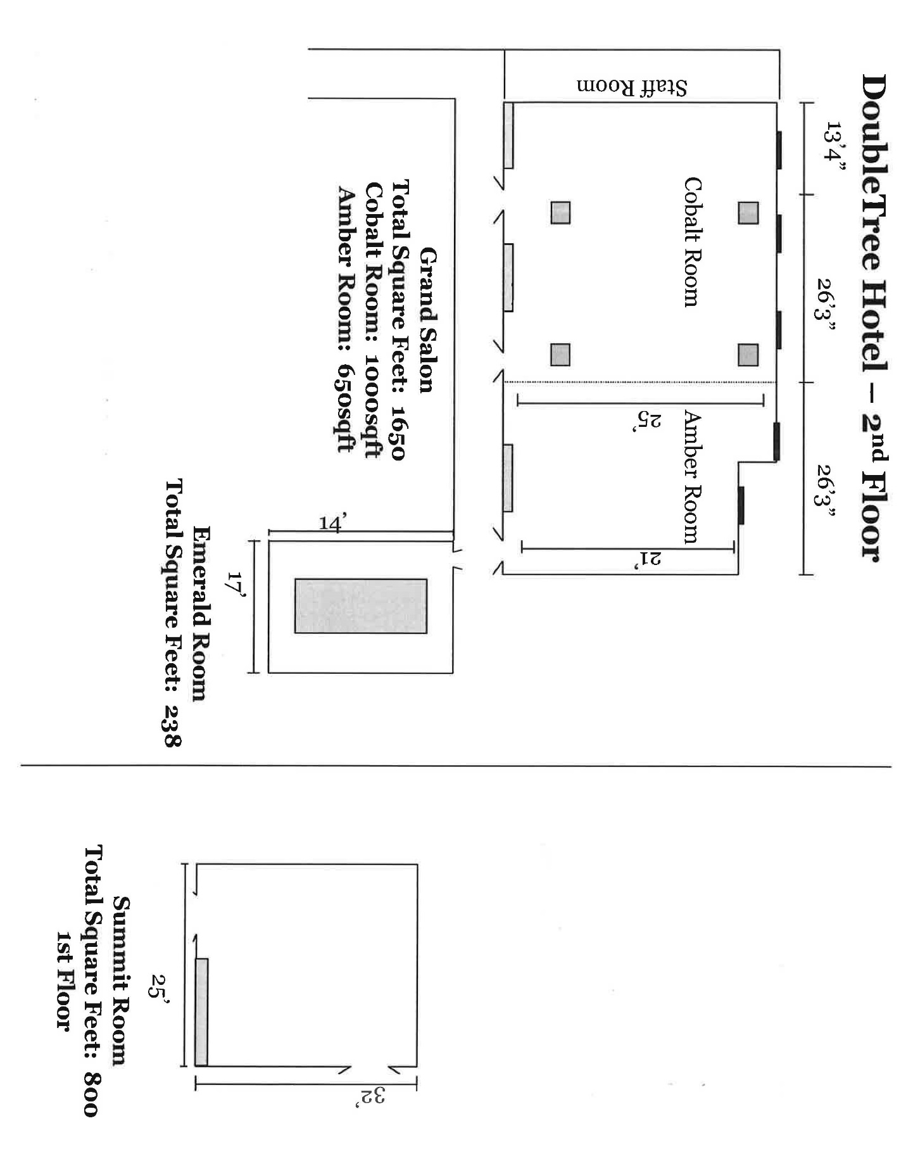

2 tickets per registered member; please bring conference nametag to Dr. Craig Albert for your tickets.
Pajari panelists are peer-reviewed and selected to present based on quality of overall research paper judged by a committee. An award is presented to an undergraduate on this panel based on written paper and oral presentation.

